ITP 120VT Module 8
Laboratory

In the Assignment tab of our Portal page download the file itp120mod8_1718.jar and itp120mod8deitel.jar. The second one has the examples from the textbook. The first one is the one we will be looking at in this module. There are a number of packages in this file. YOU WILL ONLY BE TURNING BACK IN A PACKAGE NAMED dwolffmod8 (except with your name) with the programs shown at the bottom of this document
In the lab module, write your comments in the text box (see the syllabus for information). Attach your jar file back in the Assignment and submit it back through the portal.

We will be looking at a variety of classes that are included in the Java Frameworks. Your goal is to get an understanding on when each class is appropriate. Do you need your collection sorted? Do you need duplicates removed? Does order matter? Do you have key/value pairs?

Watch the movies for the module.

Turn in a jar zip file that has three of the following four (you can pick which three). If you pick the last one, you will need an extra file (the blueprint).

#1. Write a program named Dups.java that asks the user to input a line of text from the keyboard. You output should be
- the list of words in the sentence alphabetically including duplicates
- the list of words in the sentence alphabetically removing duplicates.
You need to remove punctuation. Make certain to ask the user if they want the output to be case sensitive or not.

#2. MergeFiles.java Write a program that will read in two files of ints and merge their data. You can assume that the values are all on one line and separated by spaces. Make certain to present the user with two file dialog boxes to locate the two files. Menu items 2 through 5 should also print the results at that point.
Your menu items should be:

Choice:
- Read in the files
- Merge the files into one collection
3. Sort Numbers – Low to High
4. Shuffle Numbers - Random
5. Remove duplicates
6. QUIT!!!!

#3. StateDistribution.java Write a program that loops (end it any way that you like) and asks the user for the two letter abbreviation for a state. Keep a map of the results with the key being the name of the state and the value being the number of times that state is given. After the loop is completed print out an alphabetical list of states and how many times each one was listed. Also list the total number of different states and the total number of entries (sample output at the bottom).

#4. SE8 brought in a very very exciting concept of lambda expressions. We will never approach Java the same again! Look through the material in chapter 17 and try to complete 17.11 at the end of the chapter (also duplicated here). I have included the Invoice class in your jar file for this module.

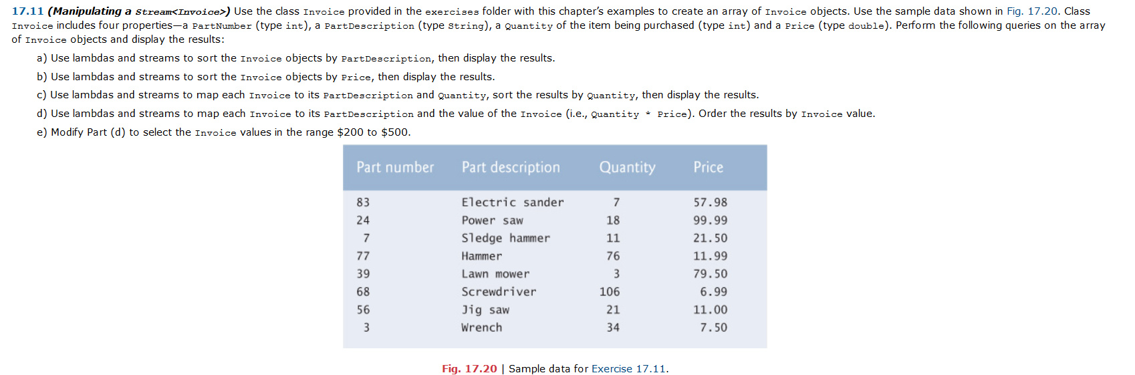

Sample Output
#1
We're going to arrange a sentence into alphabetical order.
Ok, what's your sentence?
I love Java and Java loves me. Me me me. Java loves me.
Does case matter? If it does, capitalized words will come first.
Enter true or false:
false
Here is the list of words in alphabetical order:
and i java java java love loves loves me me me me me
Here is the alphabetized list without duplicates:
and i java love loves me

#3
Give me a two letter abbreviation for a state in capitals: (TYPE DONE WHEN DONE)
AZ
Give me a two letter abbreviation for a state in capitals: (TYPE DONE WHEN DONE)
AZ
Give me a two letter abbreviation for a state in capitals: (TYPE DONE WHEN DONE)
AZ
Give me a two letter abbreviation for a state in capitals: (TYPE DONE WHEN DONE)
TX
Give me a two letter abbreviation for a state in capitals: (TYPE DONE WHEN DONE)
SD
Give me a two letter abbreviation for a state in capitals: (TYPE DONE WHEN DONE)
VA
Give me a two letter abbreviation for a state in capitals: (TYPE DONE WHEN DONE)
VA
Give me a two letter abbreviation for a state in capitals: (TYPE DONE WHEN DONE)
PA
Give me a two letter abbreviation for a state in capitals: (TYPE DONE WHEN DONE)
DONE
The number of different states entered was 5
Here are the number of times each was entered:
AZ - 3
PA - 1
SD - 1
TX - 1
VA - 2

The total number of entries was 8

